INTERNSHIP REPORT

On
Company Training Internship (60 Hours)
Submitted in partial fulfillment of the requirements for
FYUGP – Bachelor of Science in Computer Science (B.Sc. CS)

Title Page
Title: Internship Report on Library Management System
Organization: ZIUKE INFOTECH THRISSUR
Duration: 60 Hours
Course: FYUGP B.Sc. Computer Science
Register No: PNAYSCS027
Internship Type: Company Training
Technologies Used: Python, Django, HTML, CSS
Submitted by:
Student Name: Sachin Thankachan

Submitted to:
Department of Computer Science
College Name: Prajyoti Niketan College
University Name: Calicut University
Academic Year: 2024–2028

Acknowledgement

I would like to express my sincere gratitude to the organization for providing me with the opportunity to undertake a 60-hour internship as part of the FYUGP B.Sc. Computer Science curriculum. This internship helped me gain practical exposure to real-world software development practices.
I am thankful to my internship mentor and trainers for their continuous guidance, encouragement, and technical support throughout the training period. Their valuable insights helped me understand industry-level development methodologies and technologies.
I also extend my heartfelt thanks to the Head of the Department and faculty members of the Computer Science Department for their academic support and encouragement. Finally, I thank my parents and friends for their constant motivation.

Executive Summary

This internship report documents the company training internship undertaken at Ziuke InfoTech for a duration of 60 hours. The primary objective of the internship was to bridge the gap between academic learning and practical industry exposure.
During the internship, I received training in Python programming, Django web framework, and front-end technologies such as HTML and CSS. The practical component of the internship involved developing a Library Management System, which focuses on managing users, books, registrations, and borrowing of books.
The internship emphasized hands-on learning, teamwork, problem-solving, and professional ethics. This experience enhanced my technical skills, confidence, and understanding of software development life cycles.

Internship Certificate

Table of Contents

- Organization Profile…………………………………………………….……6
- Internship Overview…………………………………………………….……7
- Internship Experience – Library Management System………………………8
- Learning Reflection…………………………………………….….………...10
- Appendix……………………………………………………….……………11

Chapter 1: Organization Profile

1.1 Introduction
The internship was carried out at a Technology Organization that specializes in software development, technical training, and IT solutions. The organization focuses on providing industry-relevant training to students and aspiring professionals.
1.2 Vision and Mission
Vision:
To empower learners with practical technical skills and prepare them for the IT industry.
Mission:
- To deliver quality technical training
- To promote hands-on learning
- To develop industry-ready professionals
1.3 Services Offered
- Software Development
- Web Application Development
- Technical Training Programs
- Internship and Skill Development Programs
1.4 Organizational Structure
The organization follows a structured hierarchy including:
- Project Manager
- Technical Trainers
- Developers
- Interns and Trainees
1.5 Work Culture
The organization promotes a professional and collaborative work environment. Interns are encouraged to ask questions, participate in discussions, and explore innovative solutions.

Chapter 2: Internship Overview

2.1 Internship Duration
The internship was conducted for a total of 60 hours, divided into:
- Theory sessions
- Hands-on coding practice
- Project-based learning
2.2 Objectives of Internship
- To gain practical exposure to web development
- To understand Django framework architecture
- To apply theoretical concepts in real-time applications
- To develop problem-solving and analytical skills
2.3 Internship Schedule
- Week 1: Python basics and introduction to Django
- Week 2: Django models, views, templates
- Week 3: Frontend integration using HTML & CSS
- Week 4: Library Management System development and testing
2.4 Tools and Technologies
- Python
- Django
- HTML
- CSS
- SQLite Database

Chapter 3: Internship Experience – Library Management System

3.1 Project Overview
The Library Management System is a web-based application designed to manage library operations efficiently. It helps administrators maintain book records, manage user information, and monitor book borrowing and return activities. Users can search for books, borrow available books, and return them through the system, reducing manual work and improving accuracy.

3.2 Objectives of the System
- Automate library operations
- Manage book and user details efficiently
- Track book borrowing and return activities
- Reduce manual paperwork

3.3 System Modules
3.3.1 Admin Module
- Login authentication
- Book creation, updating, and management
- User data management
- Monitoring book issue and return records
3.3.2 User Module
- User registration and login
- Searching and borrowing books
- Returning books and viewing borrowing history
3.4 Technologies Used
- Python: Backend logic
- Django: Web framework
- HTML: Page structure
- CSS: Styling and layout
3.5 Development Process
The system was developed following these steps:
- Requirement analysis
- Database design
- Backend development
- Frontend design
- Testing and debugging
3.6 Challenges Faced
- Understanding Django MVC architecture
- Form validation
- Connecting frontend with backend
- Debugging errors
3.7 Solutions Implemented
- Regular practice of Django examples
- Using Django documentation
- Mentor guidance and peer discussion

Chapter 4: Learning Reflection

4.1 Technical Skills Gained
- Python programming proficiency
- Django framework understanding
- Web development fundamentals
- Database handling
4.2 Professional Skills Developed
- Time management
- Team collaboration
- Communication skills
- Problem-solving ability
4.3 Outcome of Internship
The internship enhanced my confidence and prepared me for advanced learning in web development and software engineering.
4.4 Future Scope
This internship has motivated me to explore:
- Advanced Django projects
- Full-stack development
- Cloud deployment

5) Appendix

- Internship photo
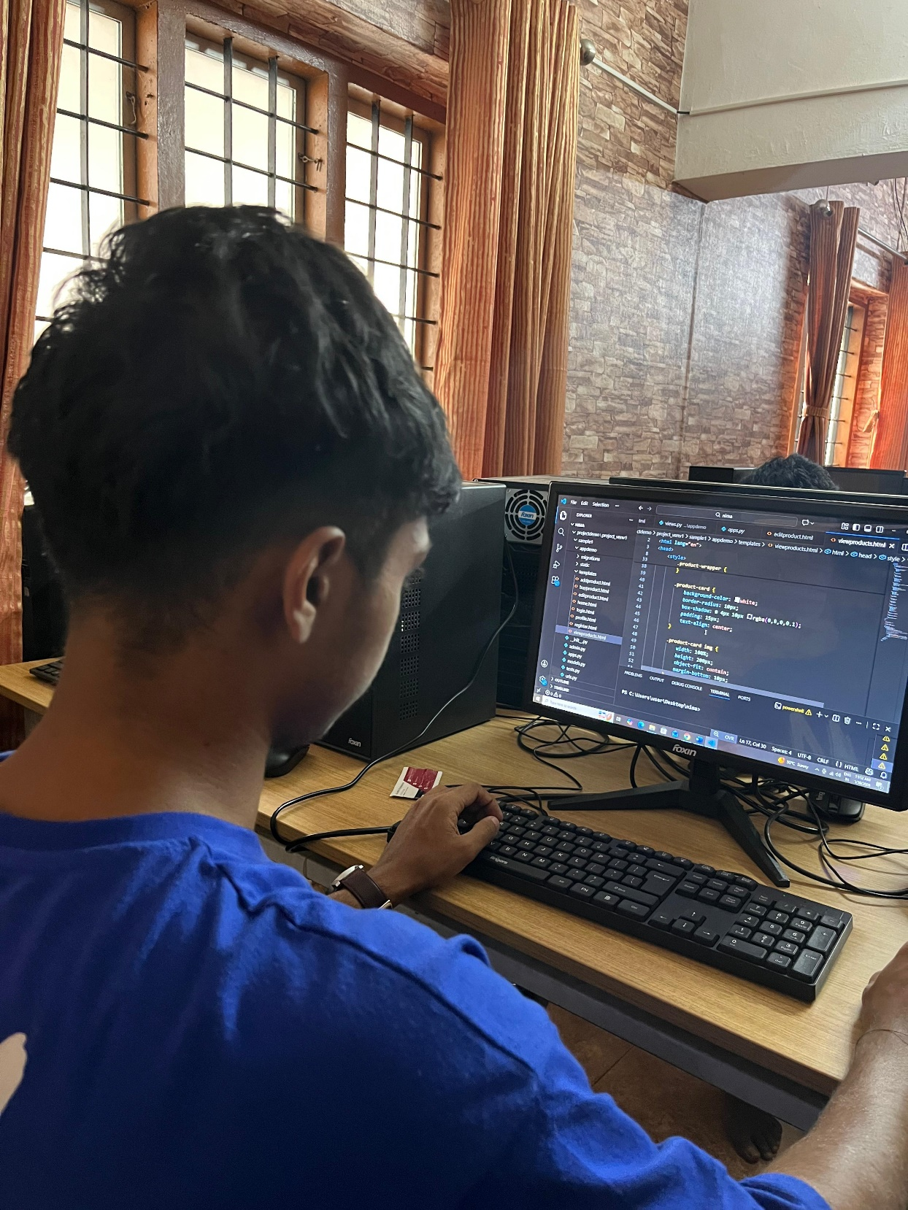
B. Worksheet
- Click here

